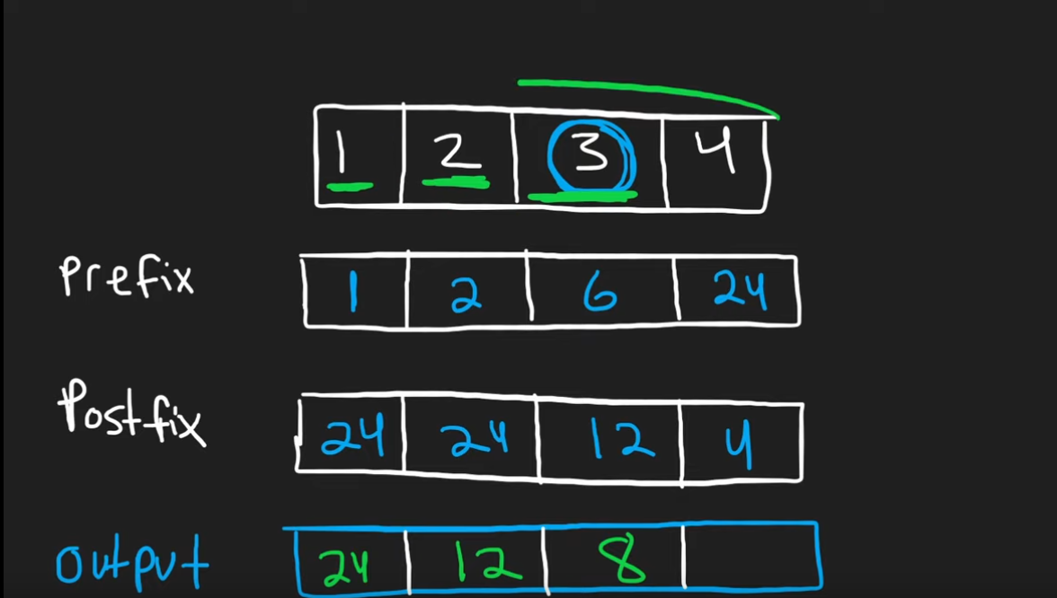

1 2 3 4

Front to back => 1 2 6 24

Back to front => 24 24 12 4

For each number in array, multiply prefix product(before the number in prefix array) with postfix product (comes after the postfix for the number in postfix array)

Return output array

**CODE**

n = len(nums)

output = [0]*len(nums)

# computing prefix

prefix = 1

for i,num in enumerate(nums):

output[i] = prefix

prefix *= num

postfix = 1

# computing postfix

for i,num in enumerate(nums[::-1]):

output[n-i-1] *= postfix

postfix *= num

return output